**Maven Cucumber Junit framework for Web Automation:**

Steps for running the project:

1. Clone the project from GitHub - https://github.com/Jagadeesh569/CucumberJunitProject.git
2. Import as maven project into workspace
3. Perform clean build to check any compilation errors
4. Verify the local chrome browser version. If it is anything other version 90, respective driver exe file has to be downloaded and placed at below location. There is a folder *drivers*.

**ProjectPath****\drivers\chromedriver.exe**

1. Cucumber Reports location - **CalculatorAssignment\target\Report${timestamp}\cucumber-html-reports\**
2. Mvn command - **mvn test -Dcucumber.filter.tags="@smoke" -DBrowser="Chrome"**

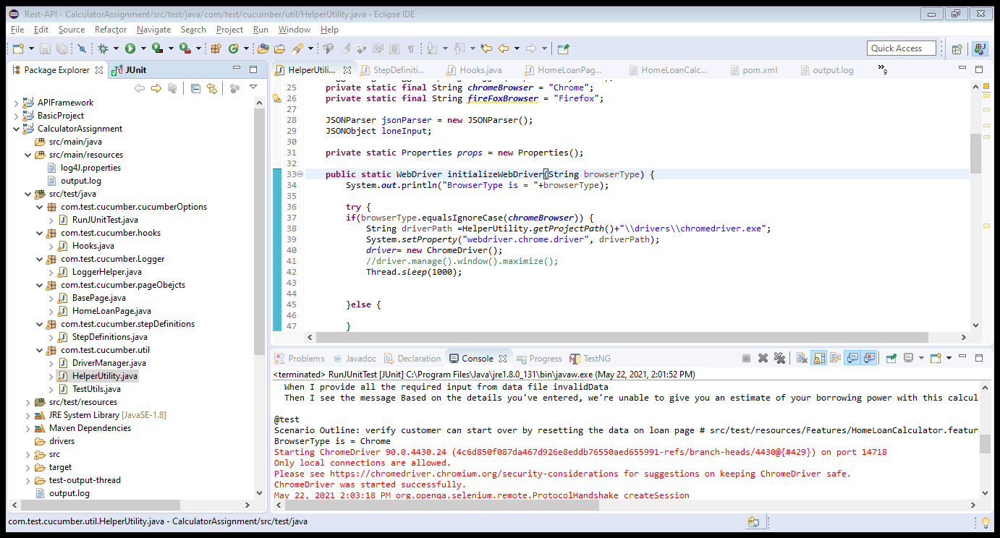

Folder Structure :

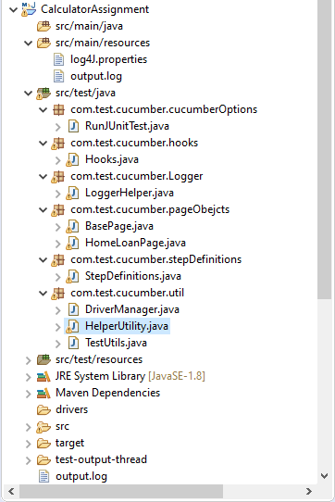

Cucumber Report:

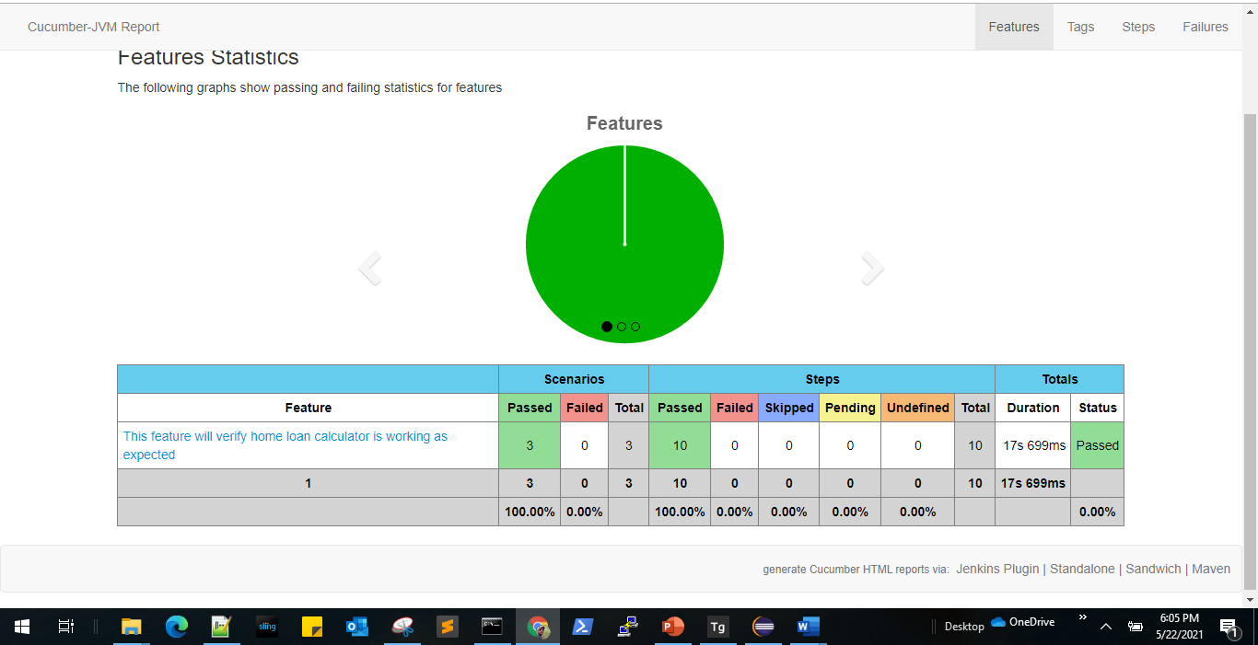

GitHub Project:

